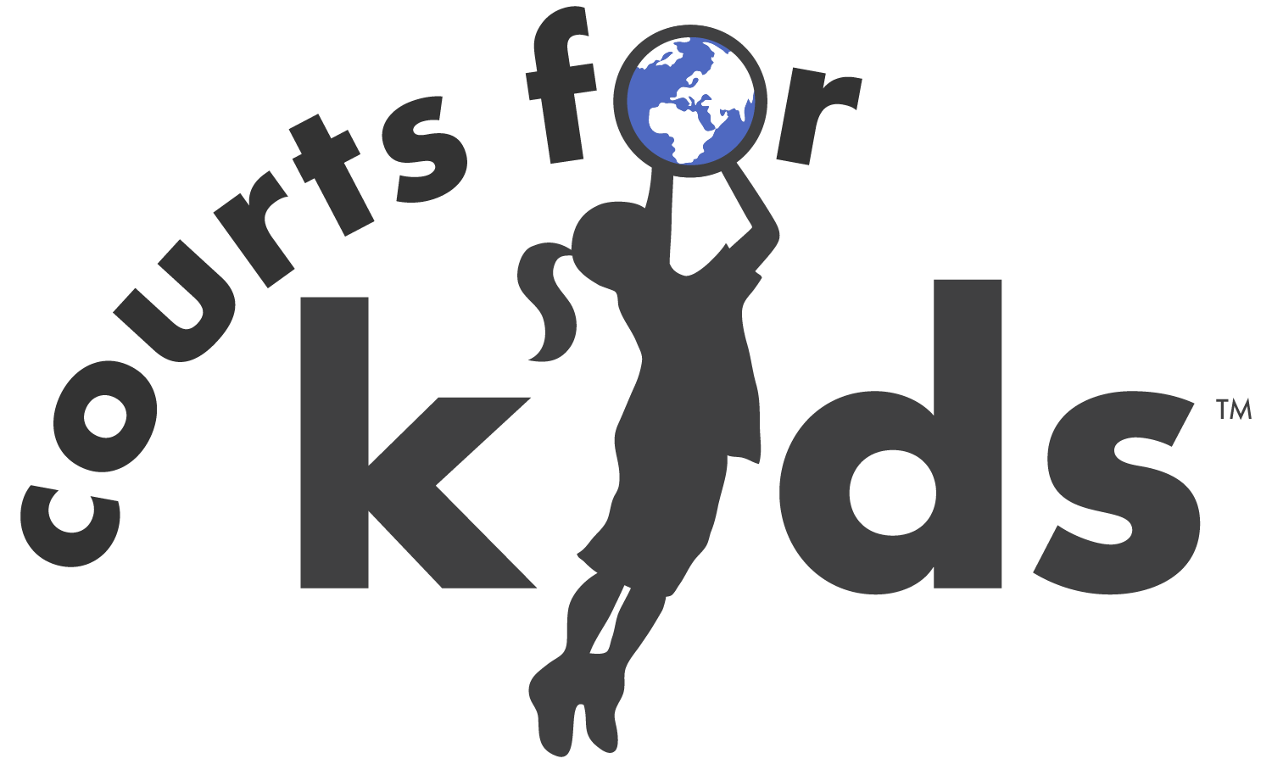

Bulanda, Kenya

University of Texas Athletics 2026

Complete all forms/dietary/medical needs online
- Go to www.courtsforkids.org/upcoming and login to your trip.
- Use your existing login information to sign in. Do not create a new account.
- Fill out/modify all the forms. This is very important as it provides us with any food allergies or restrictions, medical conditions, provides us with the information to issue tickets and serves as our waiver forms. Please be accurate with your medical and dietary needs. PLEASE COMPLETE ALL TASKS IN YOUR ACCOUNT no later than one month prior to departure!
4. If any updates/changes are after the due date there is no guarantee we will be able to accommodate the dietary and medical needs.

Flight Information
All flights are on KLM
Date Fl. # Airport Dep. Airport Arrival
6/23 662 Houston 3:20 pm Amsterdam 7:45 am (24th)
6/24 565 Amsterdam 12:20pm Nairobi 9:55 pm
Bring money for meals in the Houston and Amsterdam airport (or pack food), CFK will provide food starting with dinner on arrival.
7/3 829 Nairobi 11:05 pm Paris 6:50 am (4th)
7/4 338 Paris 11:20 am Houston 2:45 pm
The last meal CFK is providing is dinner prior to departure from Nairobi. Any food after this will need to be purchased by you.

You are eligible for mileage points on Delta. To enroll go to www.delta.com. Please bring your FF number to the airport with you and give to agent when checking in.

Checked bag: Fit everything into one bag which can’t exceed 50 lbs or 62” (length + width + height), please aim for 30-40 lbs total. Wheeled suitcases are not permitted as they create logistic difficulties traveling to and staying in the community. Instead, please use a duffel bag, with or without wheels.
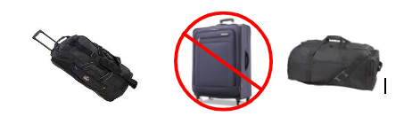
Carry-on bag: You can carry on one bag (cannot exceed 15 lbs or 45”) and one personal item. For carry on- no small roll suitcases- backpacks and small duffle bags only please.
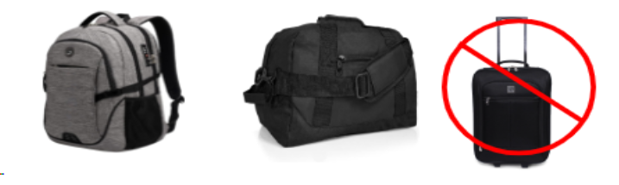
- Bring 1 or 2 changes of clothes, including work clothes in your carry-on.
- Toiletries in your carry on must be in a clear, quart sized Ziploc bag, and each item cannot be in a container bigger than 3 ounces.
- You will also need a pen in your carry on to fill out immigration paperwork on the plane when applicable.
Passport
- If you already have a passport- CHECK THE EXPIRATION DATE! Your passport cannot expire within 6 months of this trip (December 24th, 2026). If it does you MUST get it renewed!
- Your passport if the most important thing you will bring- so travel with clothes with zippers so you will not lose it or get a passport holder.
- Please make sure you have a copy of your passport on our registration system- this is required.

- In order for your passport to be valid it must be signed. Please sign it before coming to the airport.

Immigration
Courts for Kids will process an Electronic Travel Authorization that the UT staff will be physically bringing to Kenya to allow you to enter the country.

Information for immigration forms (you may be asked to fill out on the plane and present to passport control):
Phone: +254 727 032937
Immigration form cheat sheet
Passport type: Ordinary
Purpose of visit: tourism
Surname = last name
Given names = first and middle names
Date format = day / month / year

Address:
PoriCity Hotel
Junction, Sasumua Cresent, Sasumua Rd
Nairobi, Kenya

When going through immigration do not use the word “work,” but instead say you are here for “tourism.”
Prescription Medications:
Some countries have restrictions regarding bringing prescription medications through customs. To find the most up to date information, visit the International Narcotics Control Board website that provides general information for certain countries.
In general, the Center for Disease Control issues the following recommendations:

- Many countries only allow a 30-day supply of medicine.
- Keep medicines in their original, labeled containers. Ensure that they are clearly labeled with your full name, health care provider’s name, generic and brand name, and exact dosage.
- Bring copies of all written prescriptions, including the generic names for medicines. Leave a copy of your prescriptions at home with a friend or relative in case you lose your copy or need an emergency refill.
- Ask your prescribing health care provider for a note if you use controlled substances, or injectable medicines, such as EpiPens and insulin.

Community Information
Bulanda is a rural border community in Matayos Sub-County, Busia County, located near the Kenya–Uganda border. The village serves as the central hub for at least six surrounding communities. According to the 2019 Kenya census, the immediate Bulanda area has a population exceeding 27,000, with over 15,000 registered voters and an estimated 10,000+ households.

Basketball and soccer are the dominant youth sport in Bulanda and throughout Busia County, which produces approximately three-quarters of Kenya’s national-team basketball players. Despite the absence of a proper court, hundreds of children and youth currently train and play on dirt surfaces using makeshift hoops. Bulanda Primary School fields active boys’ and girls’ teams, and informal evening leagues already attract players and spectators from both sides of the border. Volleyball and netball are also popular among girls.

The court will serve over 2,000 students from Bulanda Primary and neighboring schools during the day, plus youth and adult community teams in the evenings and weekends. It will provide a structured, safe space that directly addresses documented local challenges, including youth drug abuse, school dropout, early marriage, and HIV risk. The facility will support talent development, girls’ sports participation, cross-border peace-building tournaments, and community gatherings, contributing to long-term health, education retention, and social cohesion.

Google Coordinates: 0.448381,34.101494

Average temperatures: 64-86F
Elevation: This project will take place at an elevation of 3,700 feet.
In Country Host and Staff
Your group will be led by two Courts for Kids staff members, Austin Aunyasi, who is the Courts for Kids Director in East Africa. He will be assisted by Felipe Caicedo, our Panama Director.

Transportation and Lodging
Upon arrival, you will overnight at a hotel in Nairobi. The next morning, you will be transported by private bus from Nairobi to Rusinga Island, which is approximately 8 hours away.
You will be staying in rooms at the school with mattresses and mosquito nets, which are provided. You must bring your own twin size sheets and pillow.
Bathing is bucket baths which means bathing with cold water.
You will be using latrines in the community. When outside the community while using toilets- never flush toilet paper down the toilet- it must be placed in the waste basket next to the toilet.

Food and Water
Food will be prepared by the community, so you will be eating authentic local cuisine. If you are a picky eater or a big eater, you should probably bring some snacks with you. Please make sure, though, to always attempt to eat what is given to you, and if you are dishing up yourself, only dish up what you will eat. Please accurately indicate your dietary restrictions on your online registration. We will only drink clean, potable water so please bring a large-mouthed water bottle as we pour from large jugs.
Please pack snacks for yourself. Snacks should have protein and salt.

Spending Money
There are 3 options for exchanging money:
1. Exchange money in the Nairobi airport upon arrival (sometimes money exchanging is available in one of the airports you are leaving from/traveling through as well). Bills generally need to be crisp with no writing, creases or torn in order to be exchanged. Only person(s) 18 years and older can exchange money therefore if you are under 18 you will need to have a chaperone do it for you or come prepared with one of the other two options below.
2. Bring an ATM card and withdraw money in the airport. If you are going to use an ATM card call your bank to notify them of your travel plans so you are not denied funds.
3. Pre-order local currency from your bank here in the USA. This takes planning ahead but is super convenient and hassle free.
There are no options for exchanging money once you leave the airport (meaning- we will not be making any special stops).
You will only need money to purchase airport food, souvenirs, and snacks/sodas. $50-$100 should be enough money. Please be sure to budget wisely and save enough money for airport meals on the way home.
Current currency rate is $1 = 129 Kenyan Shillings
Please be sure to budget wisely and save enough money for airport meals on the way home. Suggested around $50 for spending money.

Construction work
The work will consist of manual labor. We will work side-by-side with the locals and although it will be challenging there are jobs for every one of every physical capacity. You will be helping to load and unload a concrete mixer 300-400 times. This will take several days of work and will probably be the hardest you have worked in your life. You do not need any specific skills as the work is mostly shoveling, lifting buckets and wheelbarrowing. We want you to work hard to earn the respect and trust of the local community, as they will be working alongside you, but we also will give time to take breaks. Gloves are crucial to avoid getting blisters. Please make sure that when you work, you rinse any concrete off your skin before it dries.
Long sleeve shirts are highly encouraged to avoid cement burns on your arms (and sunburns).

Health Concerns
Each person will have medical insurance for major medical issues, which includes evacuation out of the country, if necessary. For specific policy information, please email your Courts for Kids representative.
The closest major clinic and hospital is the New Buisa Maternity and Nursing home, which is less than 5 minutes away. There are also other options, such as St. James hospital and Brimax hospital which are about 10 minutes away by car.
The four most common medical concerns that arise on our trips are:
- Dehydration and heat exhaustion - We advise you to drink more water than you think possible, and in fact you should start hydrating yourself on the plane. Gatorade is excellent to add flavor to your water and can help you stay hydrated. One of the first signs of dehydration is a headache. If this happens stop what you are doing and let your Courts for Kids representative know right away.
- Sunburns - Staying protected from the sun will be very important, so please make sure to bring sunscreen, clothes that you could work in that offer sun protection and a hat, shirt, or bandana to cover your head.
- Traveler’s diarrhea - We recommend taking one or two probiotics per day starting a week before arrival into country (check with your doctor first). Then, at the onset of diarrhea, you can take 10-15 probiotic pills to help flood your system with healthy bacteria. We also recommend bringing an antibiotic (check with your doctor) but this is only for serious gastrointestinal issues. Check with the Courts for Kids representative or chaperone before taking any antibiotics.
- Constipation - Sometimes constipation issues can happen due to a traveling, a different diet and/or dehydration. It is good to prepare for those possible issues by packing Fiber One bars, fiber supplement, or stool softener.
Immunizations Recommended by the Center of Disease Control
(Keep in mind these are recommended, not required. Check with your local doctor and make the decision best for you).
a. Routine (DPT, MMR, Polio, Chickenpox, Flu, Shingles)
b. COVID-19
c. Hepatitis A and B
d. Typhoid
e. Polio
f. Yellow Fever
g. Malaria
To protect against any mosquito borne illness prevent yourself from getting bitten by mosquitos. Use bug repellent, wear long pants and shirts at night, and sleep under the mosquito nets when provided.
Please do not pet or play with unvaccinated wildlife such as dogs.

Safety Protocol
Courts for Kids makes your safety our number one priority. Being in a safe, tight knit community with strong awareness and ownership of the project will provide local people who will be personally invested in the safety of the team. Courts for Kids also has safety protocols in place that include, but are not limited to:
- A Courts for Kids representative will lead the group while in the destination country.
- We always contract private transportation to take us directly from the airport to the community.
- We have a strict conduct policy for all trip participants which promotes the safety and security of the group. All participants are required to attend a mandatory training.
- We have secure transportation available to medical facilities in the case of any injuries.
- We will have a first aid kit with the group at all times.
- We only drink clean, potable water.
- We work with community cooks to adhere to our Safe Cooking Practices.
- We monitor the US State Department travel warnings and make travel adjustments as deemed necessary.
- Insurance coverage for all trip participants that includes evacuation with a medical escort in a worst case situation. Policy details can be provided upon request.
- A Child Protection Policy which includes background checks for all adults traveling in a group where minors are present.
- Courts for Kids may conduct a behavioral background check through a student’s school and reserves the right to refuse a participant based on the information we receive.
Safety is a team effort and every trip participant is responsible for their behavior, must use common sense while traveling, and comply with Courts for Kids representatives and trip leaders at all times.

Your Role in Safety

- Travel in groups
- Get approval from chaperone/staff member to leave the group
- Abide by construction dress code
- Never get on a motorcycle or scooter under any circumstances
- If riding in the back of a truck, must have butts on the ground
- No possession or use of drugs or alcohol under any circumstances (will be sent home at your personal expense if in violation)
- Make CFK staff aware of any health concerns immediately
- Must abide by destination country’s laws and rules
- Disclose any pre-existing health conditions in registration system
- Take personal responsibility with any serious allergies

Conduct Policy
You will be sent home if you violate Courts for Kids policies, which includes but is not limited to:
- Drugs/Alcohol- possession and/or use
- Not abiding by the destination country’s laws and rules
- Not cooperating with the CFK representative and chaperones
- Using inappropriate or abusive language or physically inappropriate or abusive actions
- Inappropriate physical relationships with members of team or community
- Visitation policy- individuals are not allowed to sleep or visit the private areas of the opposite gender
- Stay in groups unless approved by the Courts for Kids representative
- Sneaking out/Generally not being where you are told
- Damaging or defacing property
Remember- we are reflections of not only our country, communities, and Courts for Kids, but most importantly, our local host!
Technology/Phone Policy
Courts for Kids number one priority is the group’s safety. Items like cell phones make the group a target for theft. Additionally, we prioritize a full immersion experience and cell phones are often the biggest detractor. As a result, we do not allow cell phones for the duration of the time in the community. We are immersing ourselves in the culture, connecting with locals and each other therefore we want students to embrace this by agreeing to be technology free during the time in the community. Therefore, we will be collecting phones upon arrival in the community and locking them up for the week and they will be returned to students upon departure from the community. Any students found in violation of this policy will have their cell phone or other devices taken away.

Communication
Students will not be in communication with friends or family back home. Parents/guardians will be contacted if there is an illness or emergency that requires a clinic or hospital visit but generally no news is good news.
Emergency Contact Number: If there is an emergency please contact Derek Nesland at 360-521-0592, and we can decide if/how to contact your child.
To see pictures and quotes on your son/daughters’ trip we will post pictures during the trip, if possible. You can follow us on Facebook and Instagram (@courtsforkids) for these updates. Please have patience as we are confined to the limited resources the community has to offer such a limited Wi-Fi or electricity.
Handout and Gift Policy
We do not allow gifts or handouts to the communities we visit because personal handouts can:
1. Damage self-esteem of those kids who are left out.
2. Damage the message we are trying to convey- We are here to learn and grow.
3. Create a ‘beggar’ culture in a community.
4. Be something that actually won’t help the kids/community.

If you do wish to bring additional items to donate, we require them to be items that benefit the entire community and only the options listed below are allowed:
1. The community is requesting basketball jerseys or other sports items, or school supplies such as pens. These items will be left with the community leadership to distribute. Keep in mind you are not obligated to bring anything extra, but whatever you bring must fit in your one checked bag.
2. Students are allowed to leave their clothes, shoes, bedding, etc. for donation if they would like (please do not feel obligated).

- Bringing a printed picture of you with your family is also recommended in order to foster communication and relationship building with the community members. We recommended you leave it with a child/person with whom you had a special connection.

- Or you can help contribute to the sports supplies we will bring to the community to donate. To see the most updated list of supplies needed please visit our Amazon Wish list (search for “Courts for Kids” on Amazon or use QR code below). All items purchased will go directly to these communities and are greatly appreciated.
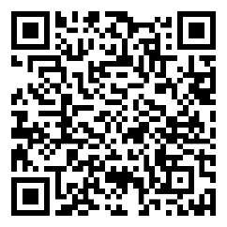
Packing list (Bag cannot exceed 50lbs)
Courts for Kids Amazon Wish List for sports supplies
Dress code at all times:
- No tank tops- shoulders must be covered
- No military or political attire permitted
- T-shirts that cover your entire top half must be worn (no low cut and no exposure of midriff).
- It is not allowed for any gender to be in public with their shirt off.
- Shorts must be longer than fingertips at your side
- Yoga pants are allowed but must have long shirt or shorts to cover bottom

Work Dress code:
- No tank tops (shoulders must be covered).
- Pants only covering the whole leg. Shorts/Capri pants are inappropriate for construction sites.
- Boots for working (rubber or construction type boots). Open-toes shoes, sandals, or similar shoes are not permitted. You must wear sturdy waterproof shoes such as water proof boots.
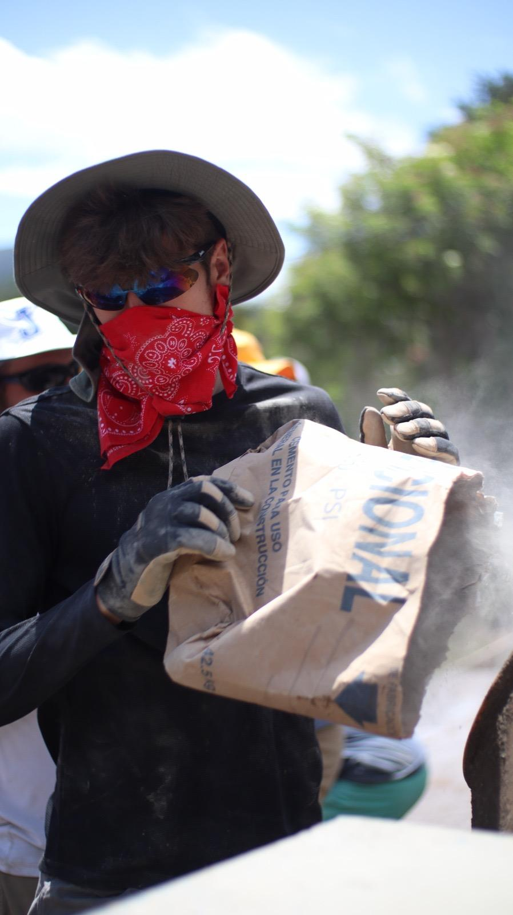
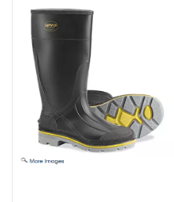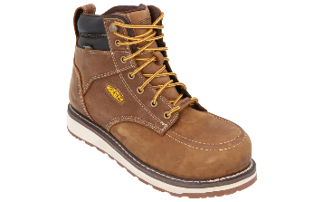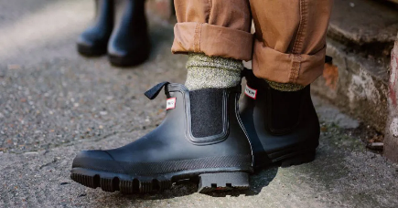
- Sunscreen and protective clothing (long sleeve shirt, long pants, hat) should be considered while on the work site.
- Arms need to be covered if you are loading the mixer (long sleeve shirt)
- Face mask or bandana must be used when loading the mixer
- Eye protection (sun glasses for example) must be worn when loading the mixer

River Bathing Dress Code:
- If you have the opportunity to swim in a river, lake or springs in a community come prepared to have a shirt and pair of shorts over your swimsuit (dri-fit recommended).

Clothes

- 5 work shirts- light colored, light weight shirts are best. At least two of these need to be long-sleeved (but we recommend more). We recommend light weight, long sleeved shirts in a light color.
- 2 long work pants (You will be able to wear these multiple times). Entire leg must be covered.
- 4-6 additional shirts to wear in evenings, for a hike, camp on the court, and travel.
- 2-3 additional pairs of pants for other activities. Yoga/legging type of pants are permitted with a long shirt to cover the bottom or a pair of shorts over them.
- A couple pair of long shorts- (long shorts are defined as longer than fingertips at your side)
- Work boots- must be closed toed, sturdy, and waterproof.
- One pair of shoes for hiking and playing sports.
- Slides or Crocs (for showering and wearing around the community)
- Socks
- Underwear
- Swimsuit (for possible communal bathing in showers and possible swimming) along with a dry fit T-shirt and shorts.
- Hats/ Bandanas to protect from sun
- Light rain jacket or poncho
- One sweatshirt/light jacket to wear on plane and in case you ever get cold
- One nice outfit for Opening Ceremonies/church/etc.- boys in button down collared shirts and slacks and girls in long skirts (past knees), or pants, and shoulders covered. Emphasis on looking professional.
- Remember to pack one pair of clothes in your carry-on in case of lost luggage.

Medical (Trip leader will have a kit with basic first aid care)
- Aloe Vera
- Advil, Tylenol or Ibuprofen
- Probiotics
- Dramamine (for car ride if you are prone to car sickness)
- Any prescription medication you are on
- Azithromycin (or similar antibiotic for traveler’s diarrhea)- REQUIRED! You will need to get this from your doctor and a picture of your medication in your name must be uploaded to your registration at least one month prior to the trip (under the “Tasks” in your registration).

Hygiene
- Package of wipes for pre-shower
- Travel toilet paper (does not have the center tube) or a roll of TP in a plastic bag. This is only needed for travel to/from the community.
- Hand sanitizer
- Basic toiletries
- Any liquids you bring in your carry-on must be under 3.4 oz. and in a clear, quart size Ziploc bag
- Feminine hygiene products (Menstrual cup is recommended)
- 1-2 Towels (quick dry camping towels are recommended)
- One bottle of liquid or spray sunscreen (to be shared with entire group)
- One bottle or spray of bug spray (to be shared with entire group)

Body wash/soap, shampoo, and conditioner will be provided by CFK but you're welcome to bring your own if you have a preference.

Safety Items- required
- Work gloves (very important)- recommend more than 1 pair
- Bandanas and/or face masks – for working around the mixer
- Sunglasses -For eye protection when working around the mixer

Hydration Items- required
- Water Bottle (wide mouthed are best- we will be pouring from big jugs and it makes it a lot easier). Maybe 2- One for water and one for an electrolyte.
- Packets of an electrolyte of your choosing- Gatorade packets, Nuun tablets, Liquid IV, etc.- plan to use 2-3 per day (to be shared with entire group).
- Required- everyone is required to bring a box containing 8 packets of Pedialyte. You can buy this variety pack box here (or find the flavor you desire): https://www.amazon.com/Pedialyte-Electrolyte-Powder-Variety-Hydration/dp/B004M1BOC6/ref=sr_1_9?crid=2PGXFGLGNQA7L&keywords=pedialyte&qid=1706041428&sprefix=pedial%2Caps%2C167&sr=8-9

Other
- PASSPORT!!!!! Your passport is the most important thing you will bring- so travel with clothes with zippers so you will not lose it or get a passport holder.
- Twin sheets and pillow
- Headlamp- electricity is not dependable (flashlight is not recommended as sometimes you need to be hands free)
- Ear plugs (in case of animal noises, loud music, snorers, etc)
- Prescription eyeglasses (if you wear contacts, bring eyeglasses along as well)
- Pen (in carry on)
- Snacks (protein and salt)- Your food and wrappers must be enclosed in zip-lock bags!
- Spending money ($50-$100 is recommended)
- Dirty clothes bag
- 1-2 garbage bags (used for multiple uses)

Optional (necessity for some, but not everyone):
- Fiber supplements/stool softeners
- Safety pins
- Anti-chaffing gels or roll-ons
- Money carrier
- Journal
- Masks
- Watch or alarm (you will not have your phone)
- Convertor/adaptor

Don’t bring
- Anything you don’t want to lose/valuables
- Electronics
- Nice Jewelry
No converter or adaptor is needed

Pack all liquid items in zip lock bags so it will not spill in your bag!

